

# FACULTY OF INFORMATION MANAGEMENT

**DIPLOMA IN INFORMATION MANAGEMENT**

(IM 110) (IM110 5A)

# INTRODUCTION TO WEB CONTENT MANAGEMENT OF DESIGN

(IMD 311)

# GROUP ASSIGNMENT:

CASE STUDY

# WEBSITE:

KAKI JERSI

# PREPARED BY:

|  |
| --- |
| NUR AFIQAH BT ABDUL MALIC @ ABDUL MALIK (2017368607) |
| NUR AMIRAH BT ZAMRIN (2017333471) SITI NAJIHA BT NAZARI (2017333913)  SITI HAISYA AMIRAH BT AMIR (2017378419) |

**PREPARED FOR:**

AHMED NOOR KADER MUSTAJIR MD EUSOFF

# GROUP ASSIGNMENT:

CASE STUDY

# PREPARED BY:

|  |
| --- |
| NUR AFIQAH BT ABDUL MALIC @ ABDUL MALIK (2017368607) |
| NUR AMIRAH BT ZAMRIN (2017333471) SITI NAJIHA BT NAZARI (2017333913)  SITI HAISYA AMIRAH BT AMIR (2017378419) |

**FACULTY OF INFORMATION MANAGEMENT UNIVERSITI TEKNOLOGI MARA**

**KAMPUS REMBAU, NEGERI SEMBILAN**

**TABLE OF CONTENT**

|  |  |  |
| --- | --- | --- |
| **NO.** | **TITLE** | **PAGES** |
| **1.** | **ACKNOWLEDGEMENT** | **5** |
| **2.** | **BACKGROUND OF THE WEBSITE** | **6-8** |
| **3.** | **NATURE BUSINESS OF WEBSITE** | **9- 10** |
| **4.** | **UX/UI OF THE WEBSITE** | **11-14** |
| **5.** | **COLOR SCHEME USE** | **15-18** |
| **6.** | **NAVIGATION OF THE WEBSITE** | **19-21** |
| **7.** | **CONTENT OF THE WEBSITE** | **22-26** |
| **8.** | **REFERENCES** | **27** |

**ACKNOWLEDGEMENT**

Praise be to Allah the Almighty and Prophet Muhammad for making this assignment a reality. We had finished the assignment that have been given by my lecturer **AHMED NOOR KADER MUSTAJIR MD EUSOFF** to us on time. This assignment had been done with all effort by us even though we faced some challenges and hurdles along the way, we still able to complete this report through hard work and perseverance.

In performing this assignment, guidance was given by a very special and respected person who deserves our greatest gratitude, Sir Kader, throughout consultations.

Last but not least, we would like to thank our classmates for being supportive and encouraging throughout making this assignment. Again, we would like to expand our deepest gratitude to all who have been directly and indirectly helped and guided us in finishing this assignment.

# Thank you.

1. **BACKGROUND OF THE WEBSITE**
   * + **WHO**

Kaki Jersi is a sports equipment shop business. It can be outdoor and they also sell sports goods to a company. Kaki Jersi is the leading customized, sublimated football t-shirts, shorts, equipment and much more online destination. Quality high at affordable prices. They deliver the freshest kit designs, the most versatile cherry fabrics, custom design and a complete line of equipment for your own club. You can order for your leisure use or even for your sports club wear. Kaki Jersi also in apparel and fashion industries category.

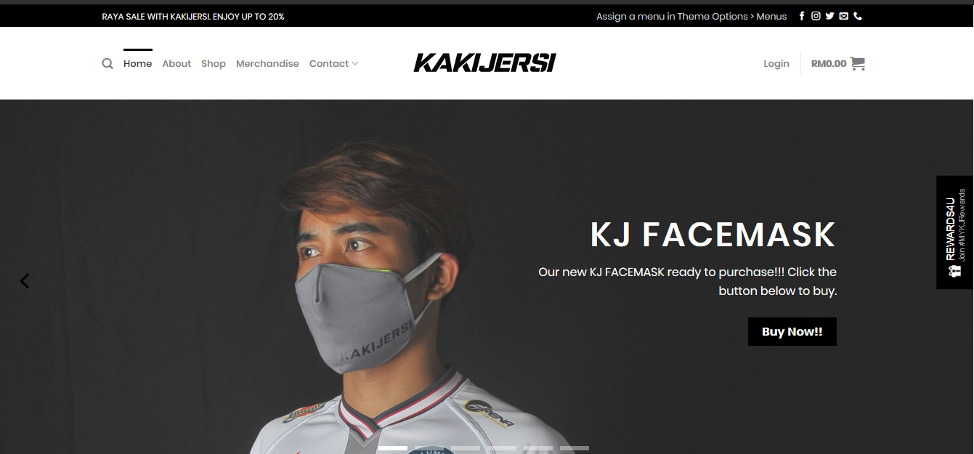

**Figure 1**

# WHAT

They’re selling lots of sportswear to buy from everyone. Kaki Jersi mainly sells customs shirts, which everyone can order according to their taste. Jersey has been one of the items they've been selling since 2015. Customers and consumers may order or even just wear outdoors for your professional sports club. Most of the time, it's for the corporate club. Now, because of the Covid-19 pandemic, they've started selling face masks to ensure everyone's safety. This is their newest product this year. You can guarantee the quality of their products, and they are very affordable.

# WHEN

Kaki Jersi was founded in 2015. We’re not quite sure when the website was created correctly, but we can ensure it was created later in 2017.

# WHY

This website is designed to inform Kaki Jersi's new and existing customers of all the information they needed to make a purchase decision. First and foremost, this website was created to advertise the goods and products of Kaki Jersi. This can ensure customer satisfaction because they don't actually have to go to the store to try to find and lookup for Kaki Jersi 's collections, Also, they can do shopping online as well, no need to physically go to the store to buy items that they want, they can just search and scroll through the items they wanted on their website and click the buy or add to cart button and enjoy shopping without wasting energy and gas.

# WHERE

Customers can search the Internet and enter the keyword "Kaki Jersi." You can scroll through and click on the website for further information. The results are displayed during your search. It can be found with any device in any Internet search engine. The value of this marketing tactic is determined by the importance of a Search Engine Optimization (SEO) website. If clients use the Search Machine to search products, services, brands and even challenges, a list of websites related to these topics is provided by the Search Engine. Therefore you need a website to return to some traffic if you want to add some of the traffic to your very own company. The more search engines like Google have the better chances of hitting new customers on this platform.

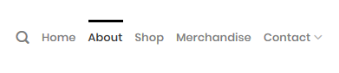

**Figure 2**

# HOW

Customers can see what goes on with their brand by Kaki Jersi. In addition to displaying its products and services, Kaki Jersi informs its customers about its company and its mission. You can create closer ties with customers and encourage conversion through useful and educational content. Your website shall notify the consumer of the products, sell and collect payment information online. This knowledge needs to be communicated to potential customers. You can find all the great content you create in your business in order to inform and involve your target audience on your website.

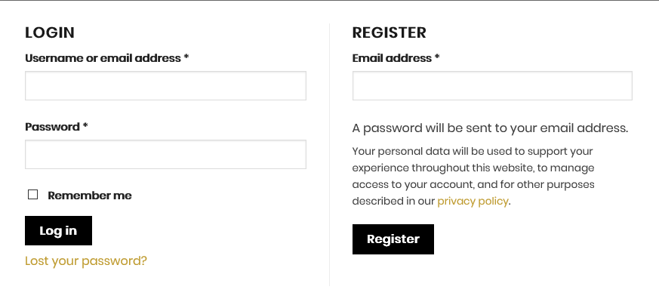

**Figure 3**

# NATURE BUSINESS OF THE WEBSITE

* + **WHO**

Kaki Jersi SDN BHD is the premier destination online to buy custom, sublimated soccer jerseys, shorts, gear and more. They provided a high quality of product with the affordable prices. All item been offer from a freshest kit designs, the most comfortable jersey materials, custom design creation, as well as a complete line of gear for your own club. Kaki Jersi manufactures their own sporting apparel in order to provide the customers with the best customization experience possible.

# WHAT

This website natures business is a manufacturing business which is a business that uses components, parts or raw materials to make a finished good that created toward e- commerce and it is usually use a general and basic style of user interface. These finished goods can be sold directly to consumers or to other manufacturing businesses that use them for making a different product. This manufacturing businesses nowadays, normally comprised of machines, robots, computers and humans that all work in a specific manner to create a product.

# WHEN

Kaki jersi started their business in 2015 by 3 co- founders in Kampung Pandan. After high demand from sport industries, they started receiving online orders and created a website in 2017 to make easier for customer that far or have a barrier to come to the store. By the business has expanded, they moved into a new factory in Batu Caves. The factory is combined between the store and factory as they want to create a new environment toward their employee and customer.

# WHY

The main reason why they want to started up this business because of the believe that can find an opportunity in making their own local brand jersey and sportswear in Malaysia as in this country that not many local brands that offer customization of jersey and sport item. Main product for this business is selling custom and printing jersey mainly for football stuff and other various types of sports netball, futsal, handball, rugby, running and many more with reasonable and affordable price to their customers.

# WHERE

It is located at NO. 7, Jalan Sri Batu Caves 9, Taman Sri Batu Caves, 68100 Batu Caves, Selangor. KakiJersi manufactures their own sporting apparel in order to provide the customers with the best customization experience possible.

# HOW

Kaki Jersi expands their products by not only producing football jerseys but other sports such as netball or handball into their collection. Having a good strategy by sponsors an event which could promote the brand more to the public or other football teams. They are joining a sport event to introduce and familiar the brand’s name and expanding their market by sponsoring official leagues outside of Malaysia such as Indonesian League. Their also use other method which is using a famous artist and celebrities to promote the brand in media social as it is a trendy method that affective to attract and maintained a customer.

# UX/UI OR THE WEBSITE

* + **WHO**

The website developer are remained anonymous but there are a dedicated page on ‘About Us’ that shared the owner of the company and their company background, social media links and contact numbers. This could be easily get in touch through any of the methods. Also, as for additional features, they provide a dedicated email which are [kakijersidotcom@gmail.com](mailto:kakijersidotcom@gmail.com) for their clients on behalf of asking any business related questions.

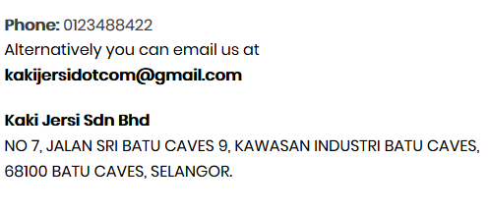

**Figure 4**

# WHAT

As a website that created toward e-commerce, they use a general and basic style of user interface. These could prove by determining their color usage, font used and where the product description are well put. The website developer created an organize product by their columns and rows. For example, there are a dedicated page just for Jerseys that they sell. It also involved a handful images and sliders to show their clients about their product in a further straightforward yet functional way. User also does not have any difficulty in finding their items. Just beside the navigation section, they inserted login button and shopping cart right at the center of the screen as the user tune in the site. This would be very beneficial for their customer to recognize what they have bought and which account that they log into.

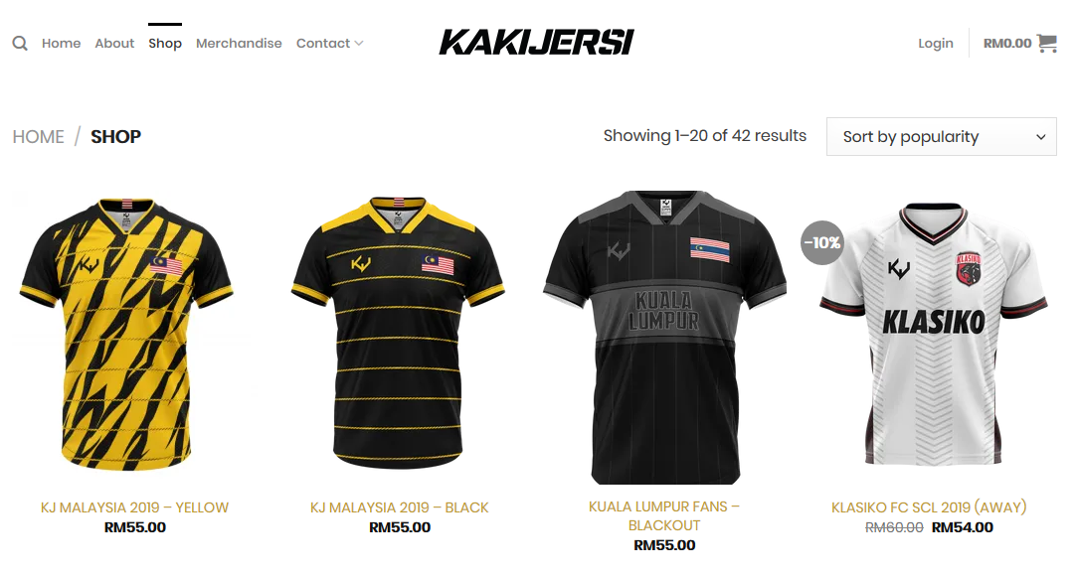

**Figure 5**

# WHEN

The website just updated their new sales items and fixing a minor typography**.** These were typos were located above footers as the creator mistakenly mix html codes with paragraph section. For instance, **‘’**Signup and receive the latest update on new arrivals, exclusive promotions, and events [contact-form-7 id="536"]**’’**

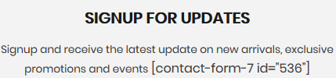

**Figure 6**

# WHY

Through our finding with this website, they use WordPress for designing their websites, keeping data of their user’s accounts, and updating any new items. This website user interface selects a minimal use of color, generous line spacing, and a well-chosen combination of typography, this website gets everything right. It shows a very simplistic use of fonts with an organize overall interface starting from the navigation section until footers. This would help the users in variation of ages and perceive as a general website that everyone can use. Once a user is logged in, users are immediately greeted with an a box appears at on the homepage with the notice for sales and promotions. This enabling and encouraging everyone automatically to click on it quickly. This strategy is working as a consumer to view more cheaper and on sales products first as well as scroll through on other items.

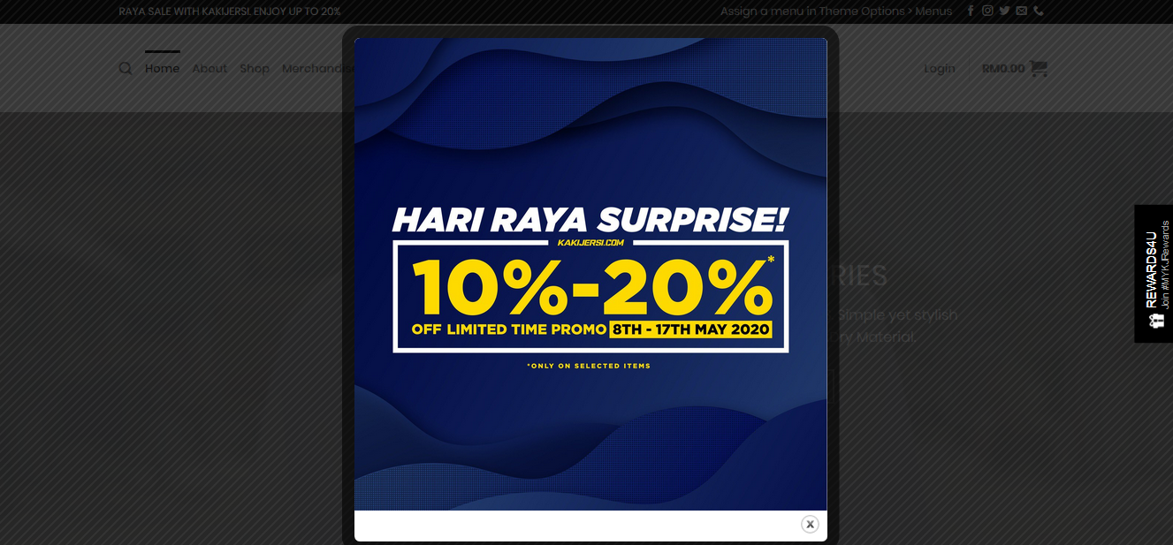

**Figure 7**

# WHERE

When scrolling down at the footer it will deliver all the information their customer needs to take which include customer care, info and follow us. This are well put as the user wanted to find any information they desired. It also shows the professionalism of the website developers. Al of the information that given are in fact accurate and same goes with all the social media links. Navigation bars are located on the right sections with their given names.

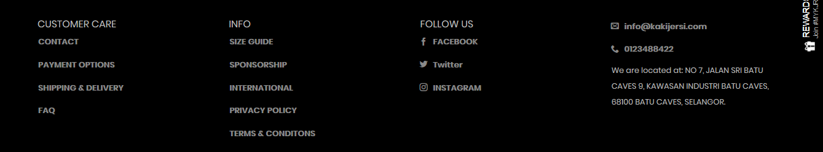

**Figure 8**

# HOW

As for ux which are user experience design, it also responsive with mobile browsers and all the buttons and links and functioning. Through ‘inspect element’, it shows that all the images and sliders are not cluttering and shows clean responsive when using mobile inspection. Besides that, all the media that been used are accurate with the products as we went to the warehouse for our ENT300 interview. The colors, materials and other information of a specific items are informed, and the usage of photographers and models are appropriate.

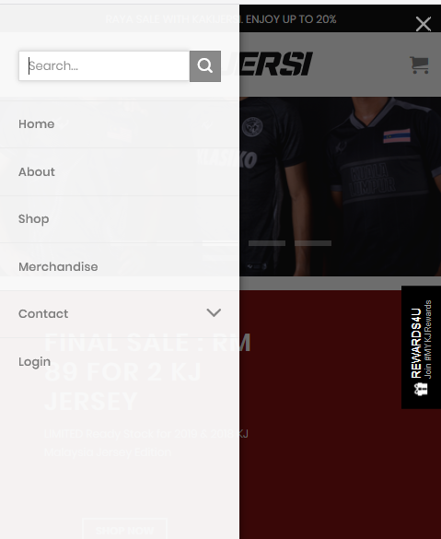

**Figure 9**

# COLOR SCHEME USE

* **WHO**

Most tend to have a distinct color scheme associated with their brand identity. For e- commerce services-based website or single product business is need to focus design that helps visitors to get information, price package etc. Kaki Jersi used plain background color to keeps their visitors' focus on their content and products.

# WHAT

The best colour scheme to use for information intensive and ecommerce websites is a white or light background, with bold dominant & accent colours. The bold dominant and accent colours give the website personality and focal points, while the plain background colour keeps your visitors' focus on your content or products This website used the black and white colour scheme and a bit of red for their website to look classic and elegant. The used of red colour is to highlight or to draw attention on important information in a text.

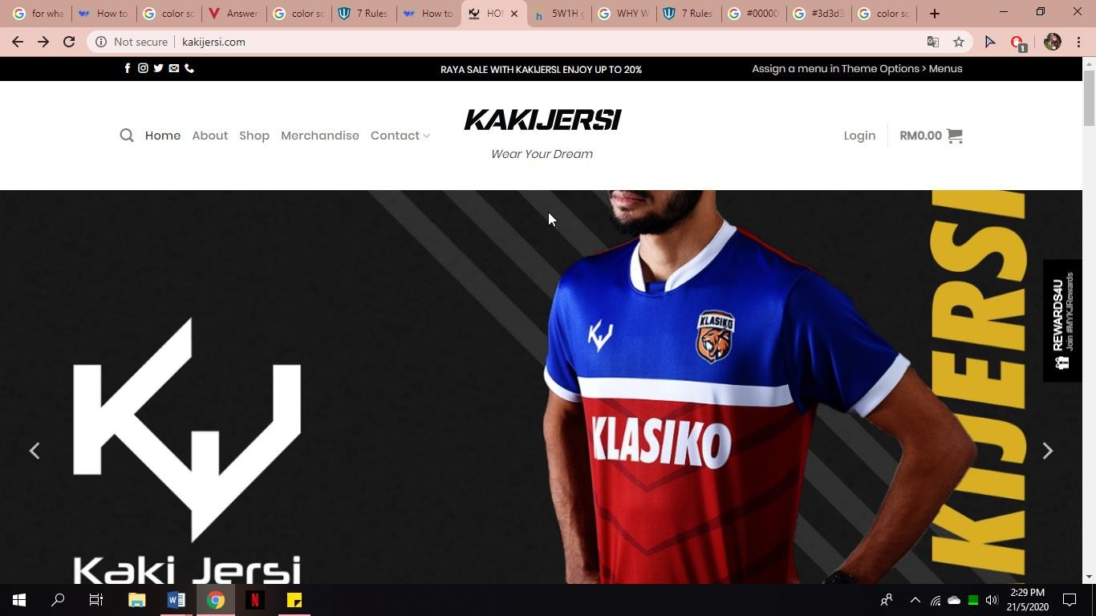

**Figure 10**

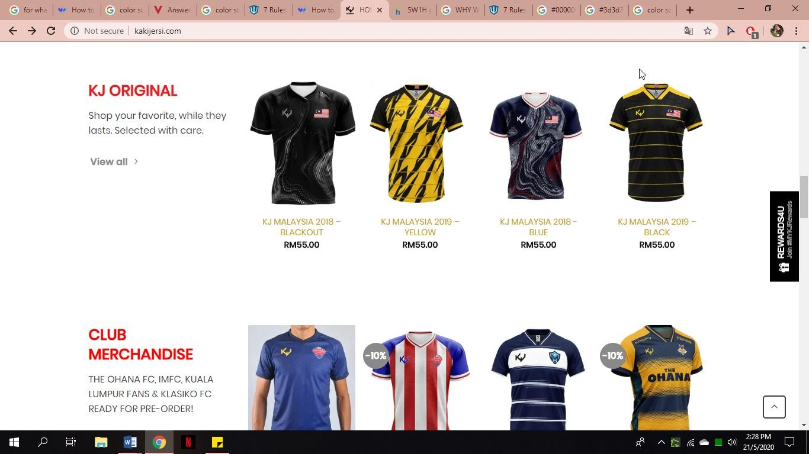

**Figure 11**

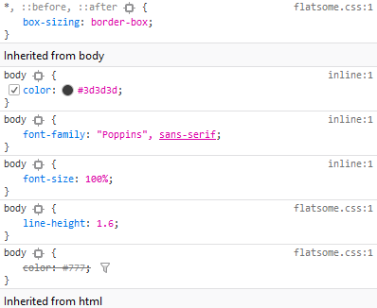

**Figure 12**

# WHEN

Kaki Jersi are trying to attract younger and energetic customer and most of their customer are male. The color scheme that they used are suitable for their target customers. The use of color scheme are very important because most of the shoppers will leave a website if it looks unattractive.

# WHY

Based on our opinion, for websites that have a lot of content, and especially a lot of words and picture of products, it’s best to choose a white background for a clean and easy-to-read look. Kaki Jersi website using black and white colour scheme to make their sies a classic look and user will become comfortable with the colour scheme.

# WHERE

For websites that have a lot of content, and especially a lot of words and picture of products, it’s best to choose a white background for a clean and easy-to-read look These websites used white (#FFFFFF) on their background and black (#000000) on header and footer. The used of red (#ff0000) is to highlight or to draw attention to important information in website.

# HOW

Colour can improve our website and brand identity. Every colour has different feelings or emotions attached to it. For kakijersi.com, when people see the colour red, it triggers emotional responses like excitement. White backgrounds and products are often used to symbolize they are fresh, clean and simple

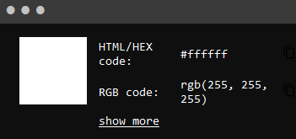

**Figure 13**

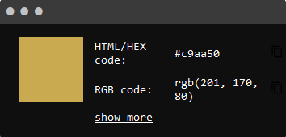

**Figure 14**

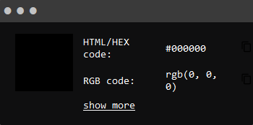

**Figure 14**

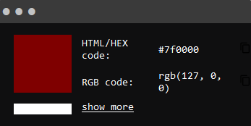

**Figure 15**

# NAVIGATION OF THE WEBSITE

* **WHO**

Based on our opinion, menu navigation exists to help us find content and it should be simple and intuitive. When looking at Kaki Jersi website, our expectation as customer is to navigate with ease and have a great experience when browsing the website. Menu navigation is an important part of web design and it's important to create well-thought- out solutions based on customer’s needs.

# WHAT

1. Responsive navigation bar.



1. The hamburger menu**.**

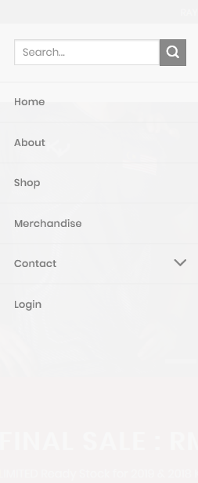

# WHEN

These websites also have mini cart icon in upper right corner of their page. The mini cart lets visitors see as each product is added to the cart without taking them out of the shopping process. They can continue seamlessly, going to the checkout page only when they are ready to proceed.



# WHY

A navigation bar is one of the main components of a website. Navigation bar is the most important one, it is in fact the first section that the user sees. when they enter a website and it links to the other main parts. Next, the hamburger menu is a navigation element we can find on this website. it’s comprised of three horizontal lines resembling, well, a hamburger. And much like its real-life counterpart, the hamburger menu is a space-saving mechanism. Kaki Jersi’s websites uses hamburger menu is to hide the navigation menu especially when customer browse their website using mobile devices.

# WHERE

Through our finding with this website, Kaki Jersi website has 5 section which is “Home”, “About”, “Shop”,” Merchandise” and “Contact”. The navigation bar very accessible and it will make it easier for user to choose where they want to in this website. These websites also have mini cart icon in upper right corner of their page. For hamburger menu. Kaki Jersi’s websites uses hamburger menu is to hide the navigation menu especially when customer browse their website using mobile devices.

# HOW

A website navigation bar is most commonly displayed as horizontal list of links at the top of each page. It may be below the header or logo, but it is always placed before the main content of the page. In some cases, it may make sense to place the navigation bar vertically on the left side of each page. It’s easy to use for customer to need information based on the navigation bar. Customer just need to click.



# CONTENT OF THE WEBSITE

* + **WHO**

The one who can access the website is customers and clients. Customers can easily access information about their business. Client can see which products or services they’re selling, prices, location and more. Anything you want to search can be found with a few clicks of the mouse. The customer is an individual or a company which purchases goods or services from another company. Because customers drive profits, without them, companies have little to give. Kaki Jersi’s customers are distinct from age, sex and race. Everyone and anyone can be a customer of theirs. Kaki Jersi customers will benefit greatly from their website. There's no need to go to the actual place to buy their products. Just a simple click away and you are off to go.

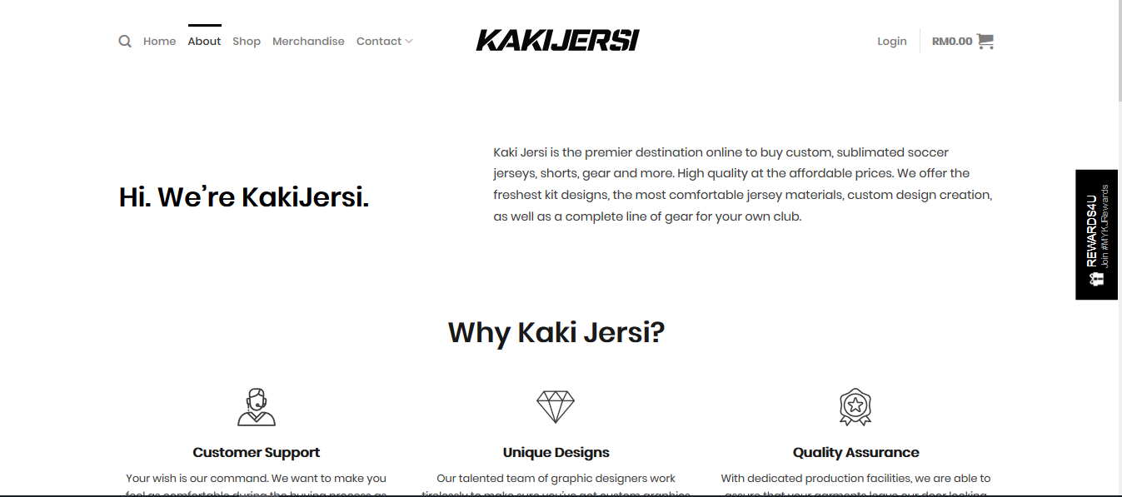

**Figure 16**

# WHAT

Based on our analysis, the website features a range of sportswear that they market to customers. When you search for keywords "Kaki Jersi" "in your search web, first thing you will see is a 10% 20% discount in conjunction to Hari Raya which will approach. This sale is on with selected items only. This sale is called Hari Raya Suprise. This sale will run from May 8th to May 17th at certain times. Then on the home page you will see different product displays that they have been selling, including jersey (original and club merchandise), basic wear of different patterns and designs. Finally, because of the Covid-19 pandemic, this time around they’re selling face masks as well, I believe it's only for a limited time. Both of these products shall be included in the price for customers’ ease of use.

Next you will find the About page, where they provide an information about their business, readers / visitors can learn more about them and what they can do and why you should choose “Kaki Jersi”. Then there's the shop section, where they show you all their products from jersey to gym. All these items are included in the price. You can also sort it out from popularity or from the lowest to the highest price. Other than that, there's a merchandise section that shows customers, all the merchandise clubs that they can buy. Merchandise is available from a number of well-known clubs, including KL City FC, Ohana FC and Malaysia Premier Futsal League (MPFL). If you are interested, you can click the button shop now to make your purchase online. Contact is the last section. Included here are the email address and company address

You can register and log in to receive updates from them. It also gives them the ability to deliver different types of services, not just deliverable. This will also benefit the client, as they always know that resources (whatever they may need) will be available to them as their needs change. Most importantly, they place customer care on each page where the customer can contact them about payment or shipping and delivery options. The mini-cart icon on the website is also appeared on the website page. The mini cart allows visitors to see if any product is added to the cart without removing it from the shopping. They also provide information on size charts, sponsorship, terms and conditions and privacy and policies. They also share all of their social media that you can also follow on each page of the website.

for the customer to contact for purchase or inquiry.

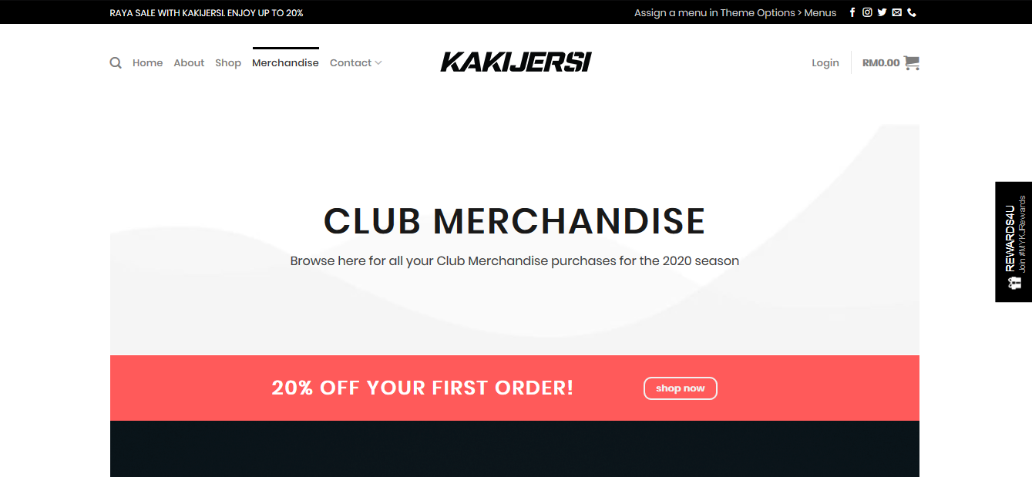

**Figure 18**

# WHEN

Customers and clients can connect and open their website at any time they choose to do so. Usually people will play phones at night because at that time we can just relax and spend some time playing phones while maybe do online shopping as well.

# WHY

Any type of communication, content or publicity that you put online will lead the customer back to your website as a backdrop to your online presence. It is also crucial that your website offers customers a simple insight into what your brand is about and what goods or services are offered. Kaki Jersi builds this website primarily for advertising purposes. They can show all their products and make knowing what they provide easier for customers. Then, informing and engaging the target audience with much more information. Customers can find out more about the product and buy it. This lets them take better procurement decisions. Next, to attract more customers. The more customers you access online, the more chances you will sell. Furthermore, Kaki Jersi does not have to constantly connect with leads indefinitely, since customers can get the details they need from the website of Kaki Jersi.

# WHERE

Kaki Jersi’s website provide search engine that is located at the top of the page on the left next to Home section. This will allow customer or clients to search product that they seek and wanted for and located them to make buying decision easier.

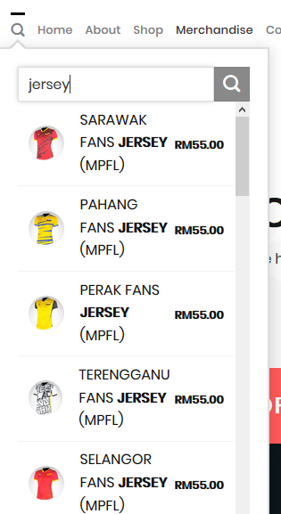

**Figure 19**

# HOW

Kaki Jersi gives customers the opportunity to see what all about their brand. Kaki Jersi also inform customers about their company and its mission in addition to showcasing their products and services. They are working to build confidence by helping consumers to know their business, the first stage in building long-term customer relations. The content you create and publish on your site helps to demonstrate to consumers that you know your things. You can help build stronger relationships with consumers and promote conversions by providing valuable and educational content. The best thing is you don't have to be there physically to still benefit from the sale. You become your own digital sales person on your website. Your platform provides the customer with information on the commodity, sells it and collects online payment information.

# REFERENCES

KakiJersi. (2020). *About us*. Retrieved June 9, 2020 from https://kakijersi.com/about/

LYFE MARKETING. (2019). *The Importance of a Website for Your Business Success*.

Retrieved from https://[www.lyfemarketing.com/blog/importance-of-a-website](http://www.lyfemarketing.com/blog/importance-of-a-website)

Nortje, JD. (2000). The nature of business activity. Fundamental Business Economics, 3-6. doi: https://doi.org/10.1016/B978-0-409-10309-0.50005-9.

The Company Warehouse. (2020). *Advantages and Disadvantages of Websites For Business*. Retrieved from https://[www.thecompanywarehouse.co.uk/blog/advantages-](http://www.thecompanywarehouse.co.uk/blog/advantages-) and-disadvantages-of-websites-for-business